**UNLOCKING INSIGHTS INTO GLOBAL AIR TRANSPORTATION**

**Introduction:**

**Overview and purpose:**

**This Global Air Transportation Network dataset is a comprehensive collection of information on airports, airlines and their routes. It contains information such as names, cities, countries, codes (IATA and ICAO) longitudes, latitudes and altitudes of airports across the world with detailed time zone and daylightsaving time data. Additionally, this includes information about airlines including their IDs, name aliases, IATA and ICAO codes, callsigns country of origin and active/inactive status. Similarly, it also covers route details such as airline sources to destination airports along with essential details like codeshare stakeholder if any stops required during this journey along with the type of aircraft being used for that particular journey. This dataset has been compiled through meticulous labour by researchers all over the world to give you a comprehensive detail into air transportation networks from around the globe.**

**Problem definition a nd Design thinking:**

**Empathy map and Brainstorming:**

[**https://github.com/libi2004/unlocking_inshighs_into_global_air_transportation**](https://github.com/libi2004/unlocking_inshighs_into_global_air_transportation)

**Empathy Map:**

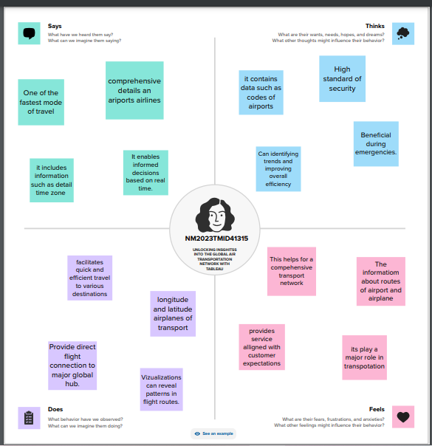

**Brainstorm:**

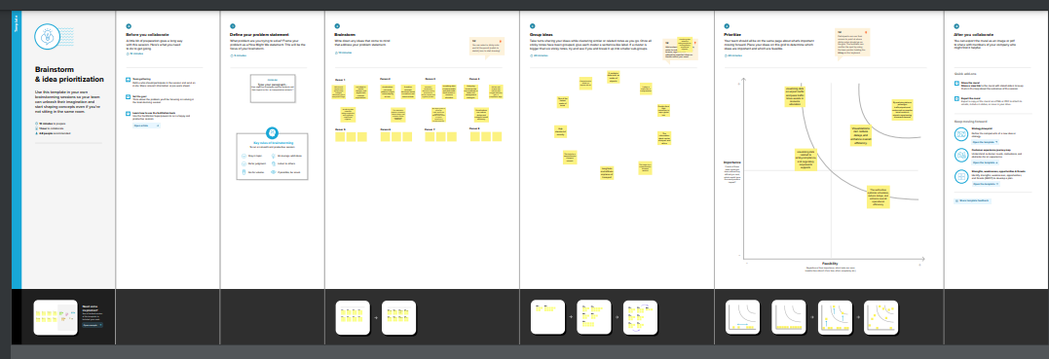

**Result:**

**Dashboard :1**

[**https://public.tableau.com/views/Dashboard1_16971958513570/Dashboard1?:language=en-GB&publish=yes&:display_count=n&:origin=viz_share_link**](https://public.tableau.com/views/Dashboard1_16971958513570/Dashboard1?:language=en-GB&publish=yes&:display_count=n&:origin=viz_share_link)

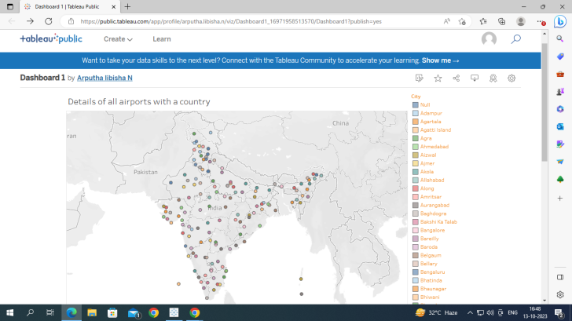

**Dashboard:2**

[**https://public.tableau.com/views/Dashboard2_16971959737470/Dashboard2?:language=en-GB&publish=yes&:display_count=n&:origin=viz_share_link**](https://public.tableau.com/views/Dashboard2_16971959737470/Dashboard2?:language=en-GB&publish=yes&:display_count=n&:origin=viz_share_link)

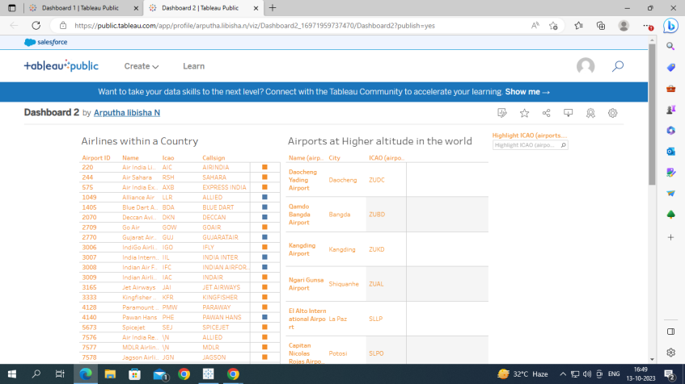

**Dashboard:3**

[**https://public.tableau.com/views/Dashboard3_16971961221650/Dashboard3?:language=en-GB&publish=yes&:display_count=n&:origin=viz_share_link**](https://public.tableau.com/views/Dashboard3_16971961221650/Dashboard3?:language=en-GB&publish=yes&:display_count=n&:origin=viz_share_link)

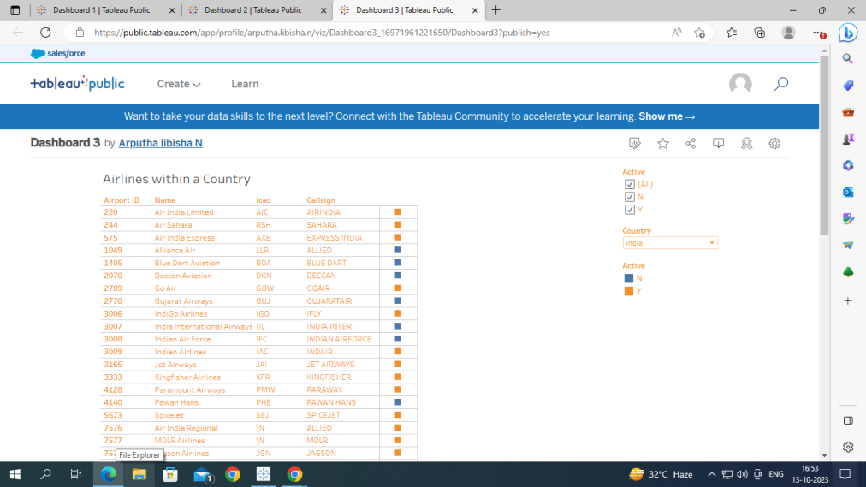

**Dashboard:4**

[**https://public.tableau.com/views/Dashboard4_16971962807920/Dashboard4?:language=en-GB&publish=yes&:display_count=n&:origin=viz_share_link**](https://public.tableau.com/views/Dashboard4_16971962807920/Dashboard4?:language=en-GB&publish=yes&:display_count=n&:origin=viz_share_link)

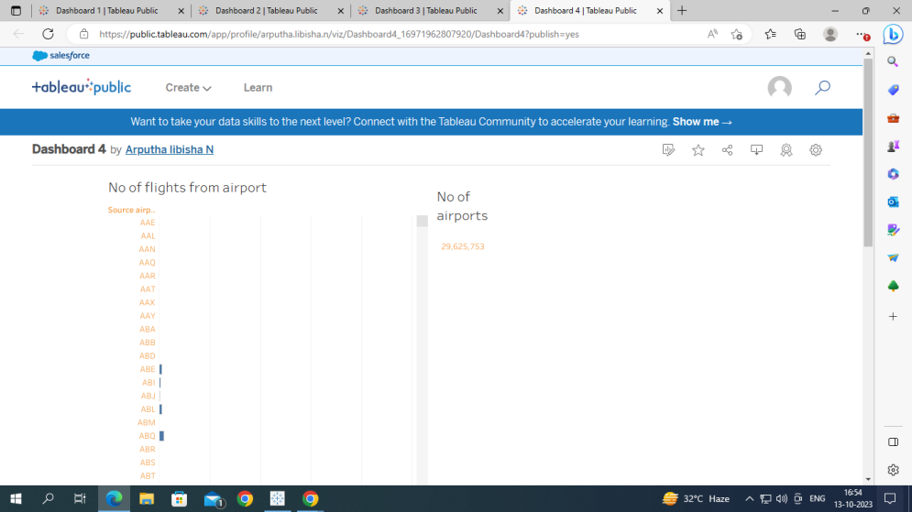

**Story:**

[**https://public.tableau.com/views/story_16971964158620/GlobalAirTransportationNetwork?:language=en-GB&publish=yes&:display_count=n&:origin=viz_share_link**](https://public.tableau.com/views/story_16971964158620/GlobalAirTransportationNetwork?:language=en-GB&publish=yes&:display_count=n&:origin=viz_share_link)

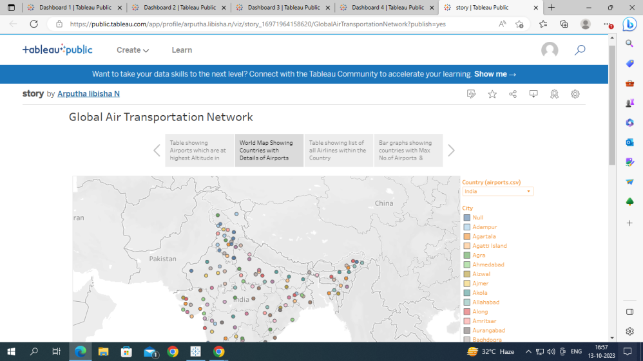

**Conclusion:**

**We have compared the world wise Air Transportation , world vs number of airports, country vs number of airports, and Details of airports with a country, Airlines with a country .This analysis will help for Global Air Transportation for overall view extract the insights from the data.**